Ubiquitous Data Access for Mobile Devices

Brian Blonski
Cal Poly
San Luis Obispo
bblonski@calpoly.edu
Matthew Schlachtman
Cal Poly
San Luis Obispo
mschlach@calpoly.edu
Jonathan McElroy
Cal Poly
San Luis Obispo
jmcelroy@calpoly.edu
Greg Gire
Cal Poly
San Luis Obispo
ggire@calpoly.edu

ABSTRACT

Permission to make digital or hard copies of all or part of this work for personal or classroom use is granted without fee provided that copies are not made or distributed for profit or commercial advantage and that copies bear this notice and the full citation on the first page. To copy otherwise, or republish, to post on servers or to redistribute to lists, requires prior specific permission and/or a fee.
Conference’09, Month 1–2, 2009, San Luis Obispo, CA, USA.
Copyright 2009 CPSU …$5.00.

Seamless data access is a coveted goal in mobile computing. Mobile devices have to deal with limited connectivity, interactivity, battery life, and storage. However, their mobile nature MAKES them ideal for centralized ubiquitous data access. In this paper, we describe the design and implementation of an iPhone application for mobile access of distributed data. We focus on quick and transparent data access by using a local cache and merged data views.
Keywords
Data transparency, Data Mobility, Distributed Systems, Ubiquitous Data Access

INTRODUCTION
As smart phones have become increasingly prolific, users demand easier access to their information from these devices. Forecasts allege that in 2009 more than 200 million smart phones will be sold worldwide [6]. Advances in technology and user demand require each new generation of these devices to include more novel features. The ability to access data from any computing device without needing a physical link or a specific application is one of these highly desired features [3]. Often, users own multiple different data storage devices, such as laptops, desktops and other smart phones, creating the desire for increased data transparency and availability of files from any location.
Highly mobile smart phones are an ideal platform in which to provide a unified view of data from multiple sources. Instead of having to physically link up their phone or install an application in order to access data, users need effortless access to their data. In this paper, we present a central mobile application that allows users to seamlessly view all of their data stored across all their devices. Users may view their data as if it were stored locally on their smart phone. Data transparency is the ability to access data regardless of where or with what is was created. By creating a directory structure based on each of the systems that device is accessing, users will easily navigate the structures they already created. The users retrieve the data they need regardless of knowledge of the system storing the data leading to increased ease of use. Also the central application relieves the user from inconsistent data across multiple devices since the phone always has access to the most current document. Users also retrieve their data from any location, taking advantage of the phone’s built-in Wi-Fi and 3G connections and balancing between the connections for performance. For on the go users, the ability to access timely information is crucial.
Anytime-anywhere data access is difficult because of network and device limitations [11]. Two of the main short comings with mobile devices are connection and storage issues. Our solution uses data hoarding combined with a cache system in order to give the users access to more data than can physically be held on the device. Data hoarding is when there is access to a network, the device anticipates the data that will be used next and downloads as much as it can. The cache system also works by storing locally the data that the users will want or are currently accessing.
In order to set up the connection between the client (smart phone) and the servers (data storage devices), there is some server side software that requires installment. The goal with the server side software is to make it simple and easy to setup. The software will then run in the background and connect with the client automatically.
The paper is organized as follows. Section 2 will discuss related works. Section 3 will explain how the user sets up the server side and uses the client software. The next sections 4 and 5 discuss the design and architecture as well as the implementation. The analysis of the software is shown in section 6 with section 7 detailing future work ideas. The conclusion of the paper is shown in section 8.

RELATED WORK
Most applications use a user-in-control model or smart-pull. Applications with low interactivity and connectivity can benefit from a true-push paradigm. Smart-pull refers to a transfer initiated by the client that minimizes user interaction to appear as if the content was delivered automatically. True-push refers to data transfer initiated automatically by the server [1].
Mobile data access is by no means an unexplored topic. Ubidata, a program described in [1,3,11], uses an true-push architecture to distribute data to mobile users. The information push paradigm is beneficial for mobile computing because it moves control away from the mobile device which usually have limited interfaces. Ubidata uses a subscriber-publisher method to share data dynamically on information channels.
Lea and Lo discuss data broadcasting techniques for mobile computing in [7]. They tackle the problem of accessing multiple data items on a broadcast channel and present methods for broadcasting and scheduling data for broadcasting based on queries by the client.
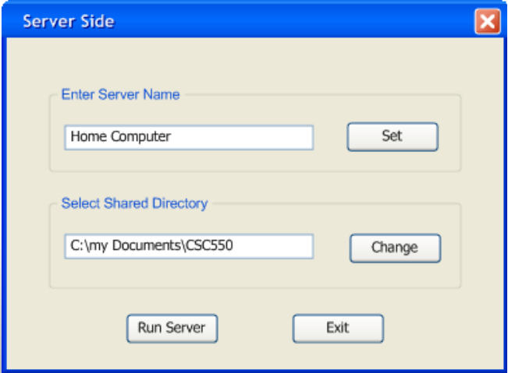
Data hoarding is another technique used in mobile data access. Caching frequently used data can reduce delay time and increase offline data accessibility. Different hoarding mechanisms are described in [2,9]. Some of the techniques proposed include hoarding through association rules, data mining, and semantic distance. Complex data hoarding techniques are outside of the scope of this project.
Figure 1 Server Side GUI
The work presented in this paper focuses on single user mobile access. However there is a lot of interest on multi-user mobility and ad-hoc networking. Huang et al. explores group mobility in a mobile network and it’s affect on replicate data allocation [5]. Leguay et al. performed a feasibility study of opportunistic data distribution to mobile users in urban settings through fixed access points in [8]. The result showed promising results with distribution over 90% of users.
An alternate approach to ubiquitous data access is a distributed file systems. Distributed file systems embody the principle that remote file access should resemble local file access [10]. This network transparency is a more dramatic approach that is more useful for multi-user environments rather than single user centralized data access.
Our overall design principle can be described as trying to make computers disappear, as discussed by Huang et al. in [4]. With the goal of moving data seamlessly between devices, Haung et al. describe three architectural principles: bring devices to the forefront, minimize the number of device features, and place functionality in the network infrastructure.

User Guide
The following section describes basic operation of our server and client software.

Server
The user runs the executable file which brings up a simple menu with two options. Error: Reference source not found shows the view of this software. First, the user either sets the name of the server by typing in a server name or the server is given a routine name such as "server 03". The name that the user sets allows them to know where the files are located on the client side. Second, the user chooses the root directory in which to share by clicking the change button which opens up a file browser. The user selects the root folder to share and clicks the "OK" button. Then the user clicks the "Run Server" button which runs the server as a background process. After the server starts a pop-up window with the server's IP address appears for the user to add to their client software. After the server starts the user no longer needs to worry about the server.

Client
Once the Server has been set up, the iPhone application can be simply executed from the Operating System of the iPhone. For the client side program to operate correctly there are a few requirements that are currently needed for our software to operate. First of all the iPhone will need to be "Jail Broken", This requirement was unavoidable for this project as it was the only way for us to have all the unrestricted privileges that we needed to make the software work. Jail breaking the iPhone is a simple process and there are various tutorials for both windows and Mac available online. One particularly useful tutorial can be found here [http://www.iclarified.com/entry/index.php?enid=1558]. During the Jail Breaking process one should also install the Open SSH package, The SSH package is required for file transfers to work between the iPhone and other computers. To install our software packages one will simply need to copy the application files to the applications directory.
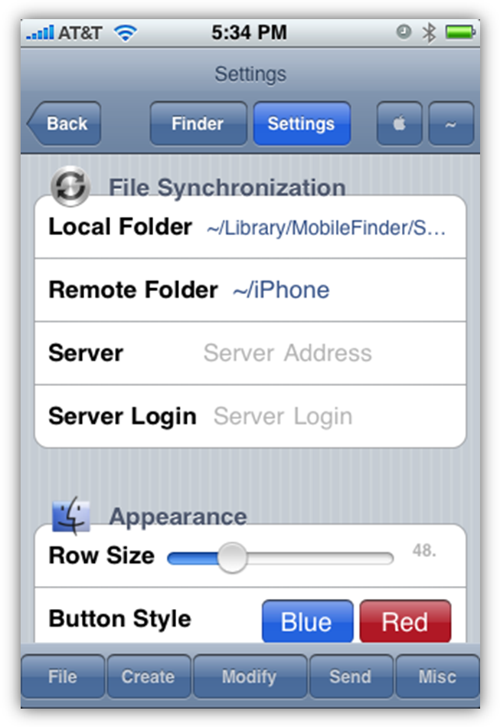
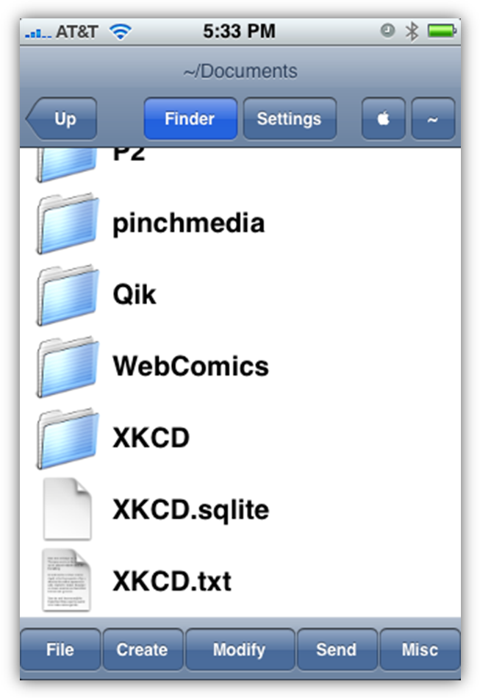
Once the client application has been opened, the user may choose to set up a server or begin working with the software. The setup is quite simple. All the user must do is click on the settings button and enter in server information including the server address and login information. Once setup of a server has been accomplished the user may attempt to connect to the server. If the server cannot be connected to the program will operate in offline mode allowing the user to view the file structure, as well as view files that have already been cached. If the client is able to connect to the server the client will receive the updated metadata from the server and display the file structure to the user. If any files have been changed from files that are currently cached the user will have the choice to update them. Normal Operation basically allows the user to view the file structure of what is being shared by the server. The user then selects a file they would like to view. If and when the iPhone looses connection, the user still has access to locally cached data. The iPhone should automatically reestablish connection with the servers when it connects to a new network.
Figure 2 iPhone GUI Prototype

DESIGN AND ARCHITECTURE
The design of our application focuses on getting quick updates without expending a lot of battery power. To do this we use a combination of smart-pull and true-push techniques. Because the iPhone has a frequently changing IP address, the iPhone must initiate the client-server communication. One the server has been contacted and given the clients address, it uses an information push mechanism to send updates to the iPhone when changes occur.

Server
When designing the server side program for our mobile data access application, our main goal was a simple unobtrusive interface that can efficiently transmit files and updates to the client.
Initially when the iPhone attempts to make a connection to the server, the server application will send a text file consisting of its metadata. This file consists of the directory structure with each file's name and size. The client uses this metadata to display a list of files that a user can request to view. This metadata file is then updated by additional text files that are sent to the client when a change is made.
The server monitors updates by detecting native I/O calls within the specified shared directory. When a file is created, modified, or deleted an update file is created containing a header containing the server's ID and then a list of changes consisting of a symbol signifying whether the file was created/modified or deleted, the filename, and its size. When a connection is established with the iPhone, the server application will immediately attempt to send the update file to the client. If there is no current connection, or the transfer fails, the server will continue to append to the update file until it is able to re-establish contact with the iPhone.

Client Architecture
There were many design choices that had to be made that were specific to how the iPhone software would behave. This section talks about how we decided to make the client software work as well as some of the tradeoffs that went into the decision making process. Deciding how the iPhone software would work.
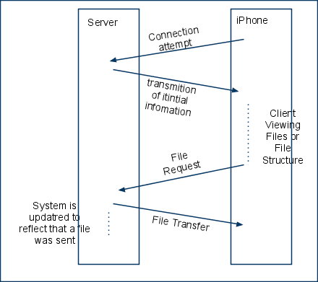
The first of the tradeoffs that had to be reviewed was the Push VS. Pull implementations that could be used in file synchronization. A push implementation would mean that the server pushes data to the phone and the phone deals with all of the data. A Pull implementation would mean that the iPhone would query the server for the necessary data and the phone would end up pulling the data from the server. In an effort to conserve power on the phone side, we decided to actually combine the two approaches. In essence the iPhone will establish a connection with the server and the server will then push the metadata to the iPhone. With the client side having the metadata the use could request a file be transferred from the server to the iPhone. In this instance the phone would pull the desired file from the server and then have it cached in its own memory.
Figure 3 Client-Server Communication
Another trade off that was discussed in the design of the client software was in the user interface. The question was whether we wanted to make it so that the file access was read only or read and write. The group decided to make the system read only as we realized that we would run into synchronization issues when files had been changed on both systems. We deemed write operations to be slightly outside the scope of our project idea. The other issue that presented itself was that it was already difficult to simply open files on the iPhone and views them properly; creating editors would simply be too difficult and would once again be outside the scope of our project and could be considered possible future work.
There are several events that can occur during the use of the software and there are two large considerations that have to be considered on the client side. The first of which was what to do when dealing with files that have become out of date with the remote copy on the server. How the client should behave when an update to a file has been detected is crucial to the design and architecture to the project. It had been decided that any files that were newer on the server and had been cached on the iPhone would have to be updated before the file could be accessed. When the server detects a file change, it resends the metadata to the iPhone and the iPhone client will simply pull the new file if it already has it cached. If the new version of the file ends up taking up more space than there is allowed in the cache, the system will simply remove the least needed item as will be talked about in the next design choice.
The second of the important events that can occur is when the Cache becomes full. When the client has pulled enough files into the cache in which case the cache becomes full, items must be removed so that additional files can be removed. In the case where a file is requested but there is no more room, the client software will simply use a weighting system which weights the importance of a file based on its last access and the number of times it has been accessed to determine which file or files need to be removed to make room for the new one. These weights can be adjusted by the user by manipulating their values in the clients configuration file.

Implementation
The following section describes the details of our iPhone and server applications. The server program was written in Java to increase portability; however, the library JNotify used for detecting native I/O operations, limits the application to the Windows and Linux platforms. Both client and server use SCP for file transfers.

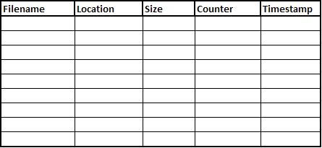
Sever
Figure 4 Cache Table
The main mechanism for TCP data transfers will be the use of the SCP (Secure Copy) protocol. This protocol gives us the ability to transfer data between the client and server securely without having to manually add functionality. The SCP protocol runs on port 22, but the protocol itself does not provide authentication and security; it relies on the underlying protocol, SSH, to provide these features. Since SSH will be setup on both the client and servers, it will be perfect for the core file transfer section of the project. SCP can interactively request any passwords required to make a connection to a remote host. For upload, the client feeds the server with files to be uploaded, optionally including their basic attributes. For downloads, the client sends a request for files or directories to be downloaded. For most applications, the SCP protocol is superseded by the more comprehensive SFTP protocol, which is also based on SSH.
The SCP protocol makes our project highly compatible and easily portable to many operating systems. SCP also includes some very useful error detection and correction protocols. It takes into account connection interruptions and deals with errors in file transfer correctly according to our design.
Once the server has been initialized, it will begin listening for a connection from the iPhone at all times, waiting for it to send its connection information. Once the server application is contacted by the client, it stores the iPhone’s IP address and means of connection (i.e. Wi-Fi, EDGE, or 3G). The Sever can then connect to the iPhone using SCP and transfer its metadata file. The client can then use SCP to pull a file from the Sever and download it into its cache memory.
The Server will continue to ping the known iPhone address every specified time interval to determine if the client still has connectivity. If the client’s IP changes or connection is lost, it is the responsibility of the iPhone to reestablish connectivity to the server.

Client
The iPhone client stores a list of known server locations in a configuration file located within the application directory. Upon opening a server file system, the client software will attempt to establish contact with the corresponding server. Assuming the connection is established successfully, the client receives the metadata file from the server. In the Event that the iPhone can not establish a connection with the server the client will operate in offline mode. Within offline mode the user will simply have the ability to view the known file system and view the currently cached files. The user may choose to reattempt server connection at any time.
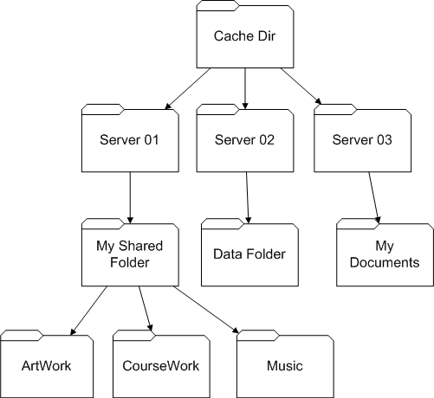
The iPhone maintains a cache directory structure, show in Error: Reference source not found, which contains all local files. The directory structure is divided by unique server identification names. Within each server folder is a metadata file that lists all files available from that server. Also contained within each server's directory are subdirectories that contain the locally cached data items in an identical fashion to the actual server’s directory structure.
Figure 5 Cache Directory Structure
Additionally, the iPhone maintains a cache table that lists the filename, location, size, number of accesses, and timestamp of each file that is locally stored on the iPhone shown in Error: Reference source not found.

Analysis
In order to assert that our design and implementation effectively allow the user to access and view their files from multiple servers, we have designed a series of tests that cover usability and performance. Each test involves text files stored in a directory hierarchy on both a desktop computer and laptop computer that are continually connected to a network. These computers have the server application installed and running, and the iPhone application is setup with their addresses and passwords. The files on each server range from 1KB - 2GB in a directory hierarchy that is at least 3 folders deep with a total memory footprint of 16GB. Additionally, the iPhone client side application is configured to use a cache size of 1GB (which will be cleared before each test is ran) and will be connected to a wireless network unless specified otherwise.
For each test, the metadata for each server (which consists of the directory structure, file names and sizes) will initially be verified to match that of its corresponding computer. Additionally, the iPhone application will be given sufficient time to connect to each server.

Multiple File Tests
The most common scenario in which our application will be used is consecutively viewing multiple distinct files from different servers. This test begins by viewing each file from each server. In files that are larger than the cache size, an error message should notify the user that they are unable to view the document due to its size (this also applies to file types that are not supported by the iPhone). After all files have been viewed and verified to match their server counterparts, the last file will again be opened to verify that it is stored within the cache and is not re-downloaded from the server. Additionally, the first file accessed will be opened again to assert that it is no longer stored within the cache and must be retrieved from the server. Finally, a few files are accessed multiple times followed by many new files being retrieved from the server and then verifying that the popular files remain in the cache.

Updated File Tests
In order to maintain consistency between our application and the servers, files that are added, modified, or deleted on the computers should be reflected in the metadata on the iPhone. The first test involves a file being viewed on the client application while server side document is being edited. The server application should recognize that a shared file is being updated and will push a notification to the iPhone indicating this. The user should then be notified by the client application that the current document is out of date and will be given the option to redownload the file. Secondly, while the user is viewing the directory structure of a computer, the directory structure of the server will be drastically altered by removing directories and files and adding new ones. The user should receive an update from the server which will prompt them to refresh their view of the server's metadata. Finally, a user will view and access a file from their iPhone multiple times to secure its position in the cache. Then will then view a different document while the previous file is edited on the server side. After allowing the update to process on the client side, the user will open the first file and verify that it is no longer cached and must be retrieved from the server.

Offline File Tests
The final tests involving the usability of our application require that all the servers are disconnected from their network connection. The user will then assert that they are able to view the most recent directory structure (metadata) for each server and view files that are stored in the cache. When the user attempts to access a file that is not cached, they should be notified with an error that the server is currently unreachable. Finally, while the servers are still disconnected changes will made to files and their directory structure. Once network connection is re-established, the user should verify that the offline updates are sent to the client and the changes are reflected in the iPhone application.

Performance Tests
The goal of these performance tests is to gauge the efficiency of our specific implementation we have chosen for our application. We will measure the amount of time that elapses between when a change made on a server is reflected on the application, signifying if our structure for updates as a simple text file is appropriate. Additionally, the average transfer time for a 1KB, 1MB, and 1GB file will be recorded over 10 separate tests on Wi-Fi, 3G, and EDGE. While speeds may vary depending upon location and wireless network, we want to verify our choice of using SCP. Finally, the performance of our cache policies will be evaluated using the above tests and any other situations we deem important.

FUTURE WORK
Our central data access application is a good start for increasing access and data transparency for users. Currently though, we can only access and view the data on the client. In the future, we want two way data access, so that users can edit data on the client and have it transfer to the server side. This includes modifying the directory structure of a server, and creating new files. Also, the current design is for a single user, in order to not deal with the concurrency issues. The eventual plan is to create multi-user client/server software in which multiple people have access and are working on the same files and a merge system will deal with any resulting conflicts.
There is also some future work that needs to be done in the area of the cache and data hoarding policies. Currently these policies are simple and basic. We used the easier policies since more complex ones are outside the scope of our project.

Conclusion
The goal of seamless data access is an important goal in the future of mobile computing. We designed a simple to use central data access application for the iPhone that allows users to view their data files from anywhere there is a network connection. Our design also deals with many of the limitations in mobile devices by using predictive data hoarding and caching to give users access to data sometimes even when the network is inaccessible. A main part of the future of OS's is certainly increased data transparency, allowing users to store data anywhere and then access it anywhere. The objective of our paper is to contribute to this research by combining the goal of transparency with mobility.

REFERENCES
1. Dynamic information dissemination to mobile users. Mob. Netw. Appl. 9, 5 (2004), 529-536.
2. Bürklen, S., Marrón, P.J., Rothermel, K., and Pfahl, T. Hoarding location-based data using clustering. Proceedings of the 4th ACM international workshop on Mobility management and wireless access, ACM (2006), 164-171.
3. Helal, A. and Hammer, J. UbiData: requirements and architecture for ubiquitous data access. SIGMOD Rec. 33, 4 (2004), 71-76.
4. Huang, A.C., Ling, B.C., Barton, J., and Fox, A. Making computers disappear: appliance data services. Proceedings of the 7th annual international conference on Mobile computing and networking, ACM (2001), 108-121.
5. Huang, J., Chen, M., and Peng, W. Exploring group mobility for replica data allocation in a mobile environment. Proceedings of the twelfth international conference on Information and knowledge management, ACM (2003), 161-168.
6. Keijzers, J., Ouden, E.D., and Lu, Y. Usability benchmark study of commercially available smart phones: cell phone type platform, PDA type platform and PC type platform. Proceedings of the 10th international conference on Human computer interaction with mobile devices and services, ACM (2008), 265-272.
7. Lee, G. and Lo, S. Broadcast data allocation for efficient access of multiple data items in mobile environments. Mob. Netw. Appl. 8, 4 (2003), 365-375.
8. Leguay, J., Lindgren, A., Scott, J., Friedman, T., and Crowcroft, J. Opportunistic content distribution in an urban setting. Proceedings of the 2006 SIGCOMM workshop on Challenged networks, ACM (2006), 205-212.
9. Neto, M. and Salgado, A. Hoarding and prefetching for mobile databases. Computer and Information Science, 2006 and 2006 1st IEEE/ACIS International Workshop on Component-Based Software Engineering, Software Architecture and Reuse. ICIS-COMSAR 2006. 5th IEEE/ACIS International Conference on, (2006), 219-224.
10. Thanh, T., Mohan, S., Choi, E., SangBum Kim, and Pilsung Kim. A Taxonomy and Survey on Distributed File Systems. Networked Computing and Advanced Information Management, 2008. NCM '08. Fourth International Conference on, (2008), 144-149.
11. Zhang, J., Helal, A., and Hammer, J. UbiData: ubiquitous mobile file service. Proceedings of the 2003 ACM symposium on Applied computing, ACM (2003), 893-900.

